**CSE112 Artificial Intelligence**， **Week 9 2019**

## Exercises And Tutorial Questions

**Part I . Multiple Choice Quiz**

1. In a conjunction, if one of the statements is false, the whole conjunction is.
   1. False
   2. Negated
   3. True
   4. Both true and false
2. The symbolization for a disjunction is...
   1. p q
   2. p  q
   3. p  q
   4. ➢p
3. Propositional logic uses symbols to stand for statements and...
   1. Nonstatements
   2. The relationships between subject and predicate
   3. Truth values
   4. The relationships between statements

4.

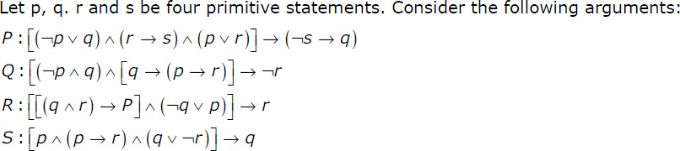

Which of the above arguments are valid?

**A** P and Q only **B** P and R only **C** P and S only **D** P, Q, R and S

1. Which one of the following is not equivalent to pq

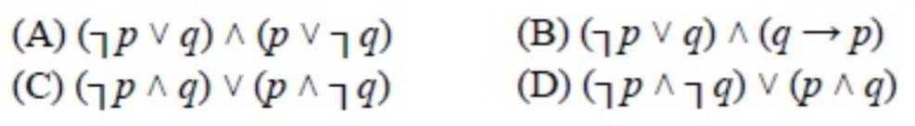

1. Consider the following propositional statements: P1 : ((A ∧ B) → C)) ≡ ((A → C) ∧ (B → C)) P2 : ((A ∨ B) → C)) ≡ ((A → C) ∨ (B → C))

Which one of the following is true? **A** P1 is a tautology, but not P2 **B** P2 is a tautology, but not P1 **C** P1 and P2 are both tautologies

**D** Both P1 and P2 are not tautologies

1. A logical sentence is called *satisfiable* if and only if
   1. it is constructed according to the syntactical specification of the language
   2. it is true under all possible interpretations in all possible worlds
   3. it can be used by an inference procedure to construct a proof
   4. there exists at least one interpretation for which the sentence is true.
2. A logical sentence is called *valid* if and only if
   1. it is constructed according to the syntactical specification of the language.
   2. it is true under all possible interpretations in all possible worlds.
   3. it can be used by an inference procedure to construct a proof.
   4. there exists at least one interpretation for which the sentence is true.
3. Which one of the following expressions is valid (or tautologous)
   1. A ⇒B

B. (A⇒B) ∨(➢A ∨➢B)

C. ➢ (A ∧➢B)  ➢ (➢A ∨ B)

D. ➢B ∧ (A ⇒B)

1. Which one of the following expressions is *unsatisfiable* (or *inconsistent)*
   1. A∨➢A

B. A⇒ (B ∧ (A ∨ B))

C. ➢(A ∧➢B) ➢ ➢A ∨ B)

D. ( A⇒B) ∨(B ⇒A)

1. Let P, Q and R be three atomic prepositional assertions. Let X denote (P v Q) → R and Y denote (P → R) v (Q → R). Which one of the following is a tautology? **A** X ≡ Y

**B** X → Y

**C** Y → X

**D** ¬ Y → X

# Part II. Answer the following questions.

## Question 1. In words, describe when an expression in propositional logic is:

1. Contingent:
2. Tautologous:
3. Inconsistent:

# Question 2. Define the following concepts precisely

1. Validity of a sentence
2. Satisfiability of a sentence

**Question 3.** Construct truth tables for the following expressions of propositional logic, and use these to decide whether the expressions are contingent, tautologous or inconsistent:

(a)(AB) OR(➢A OR➢B)

(b) ➢ (A ➢B) ➢➢A  B) (c)A (B  (A  B))

(d) (➢A  B) C  ((A  ➢B)  C)

**Question 4.** Using truth tables, prove that the following propositional logic sentence is valid:

((P Q)  (Q R))  (P  R)

**Question 5** Converting to CNF

Convert the following sentences to conjunctive normal form.

1. (A B)  C

2. A  (B C)

3. (A B) ∨ (B  A)

4. (¬P  (P Q))

5. (P  (Q  R))  (P  (R  Q))

6. (P Q)  ((Q R)  (P  R))